MNLR INFERENCES

1. Mdata :

Business problem : To classify the number of students who took which program

“Academic “ , “general “ ,”vocation”.

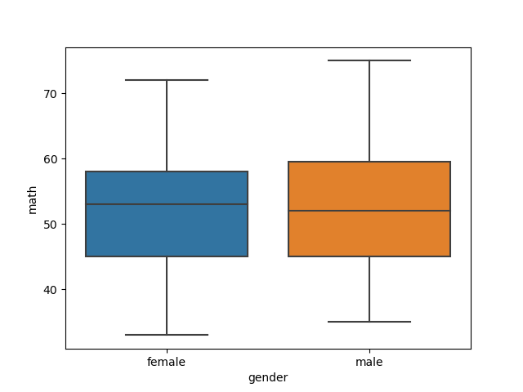

The above boxplot shows that for both males and females who took **math** :

For Female the median is at the top upper part that is in Upper quartile range Q3.

For Males the median is at the middle meaning it’s normally distributed for the boys category and lot more males have taken Maths subject even on Training data and test data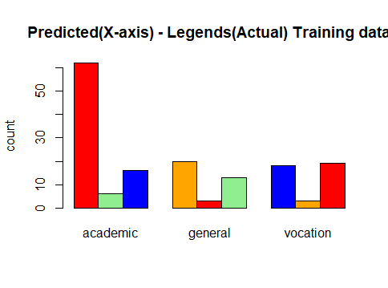

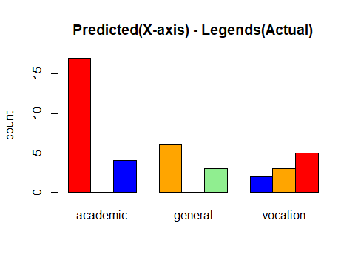

The above bar plot is after modelling the data and shows the enrollment count for academic and others

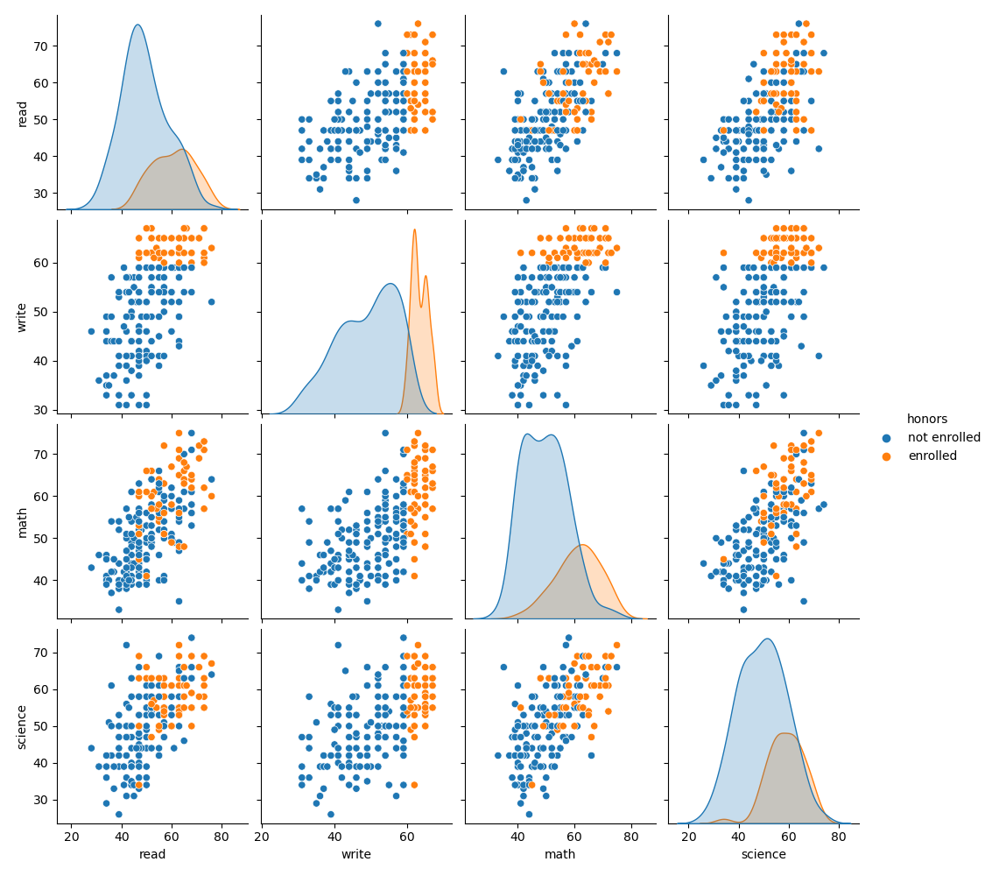

This pair plot shows that following correlation with hue of enrolled or not.

1. Almost all show some sort of correlation among them .
2. Most have not enrolled in Science.
3. Some Spike in Write for enrollment.

The program has more amount of males and have undertaken Math’s as their major

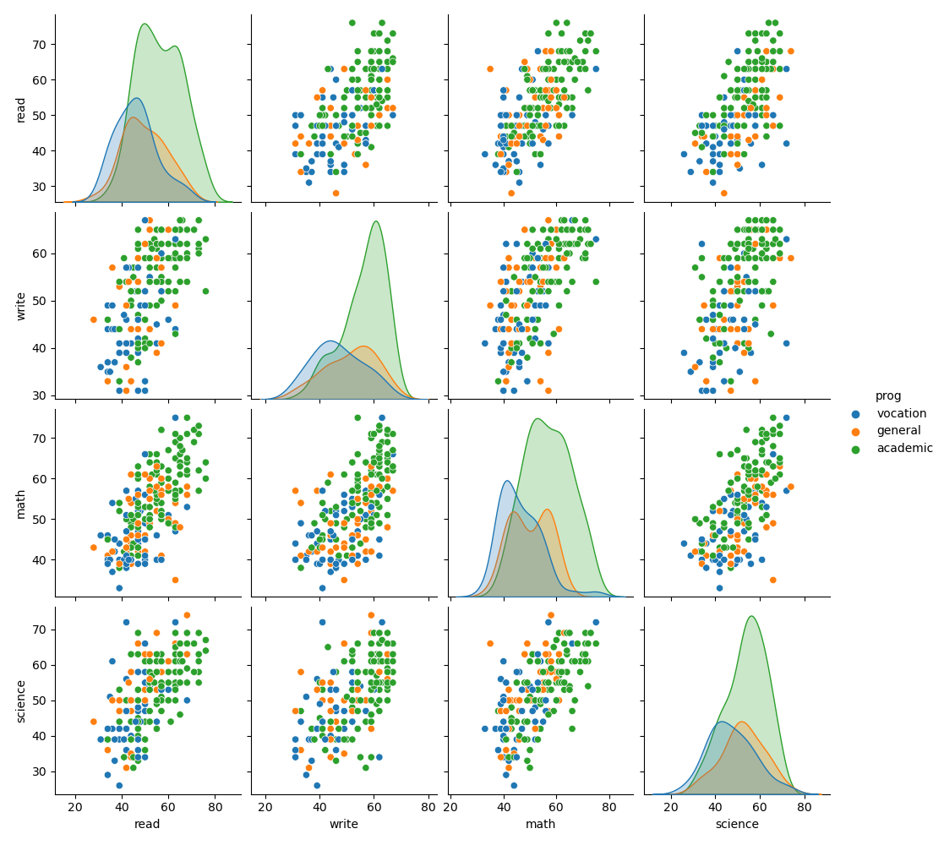

The above pair plot shows that most students have enrolled in Academic since most topics are related to study itself.

